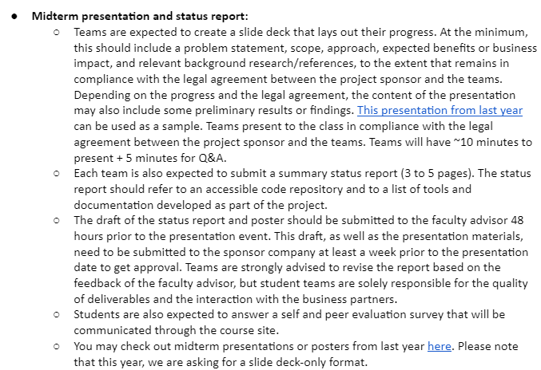

“Each team has 10 minutes to present, and each presentation will be followed by 5 minutes of Q&A. 25% of the grade will come from the midterm (presentation, report, peer evaluation).”

**Topics to cover:**

* background,
* proposal of the problem,
* hypotheses,
* data,
* methods, and
* (only optionally) early results.